Shooting

- Create a Cylinder, make it bigger or smaller (it’s up to you) rotate the x section to 90 and for position x to 1 and z to -8
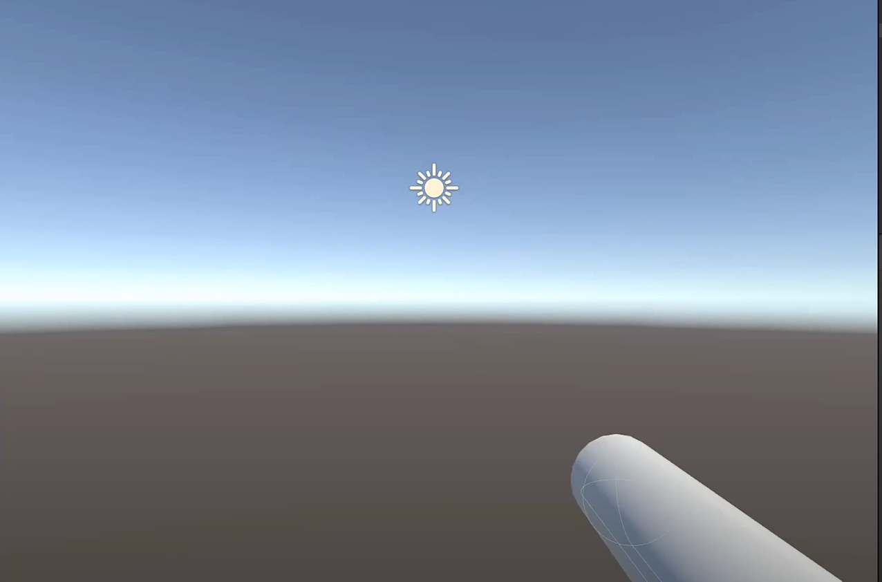
You should have something like this image.
- Remove the capsule collider from the cylinder.
- Change the cylinder name to gun and create empty name it BulletSpawnPoint.
- Add a script to gun named Gun
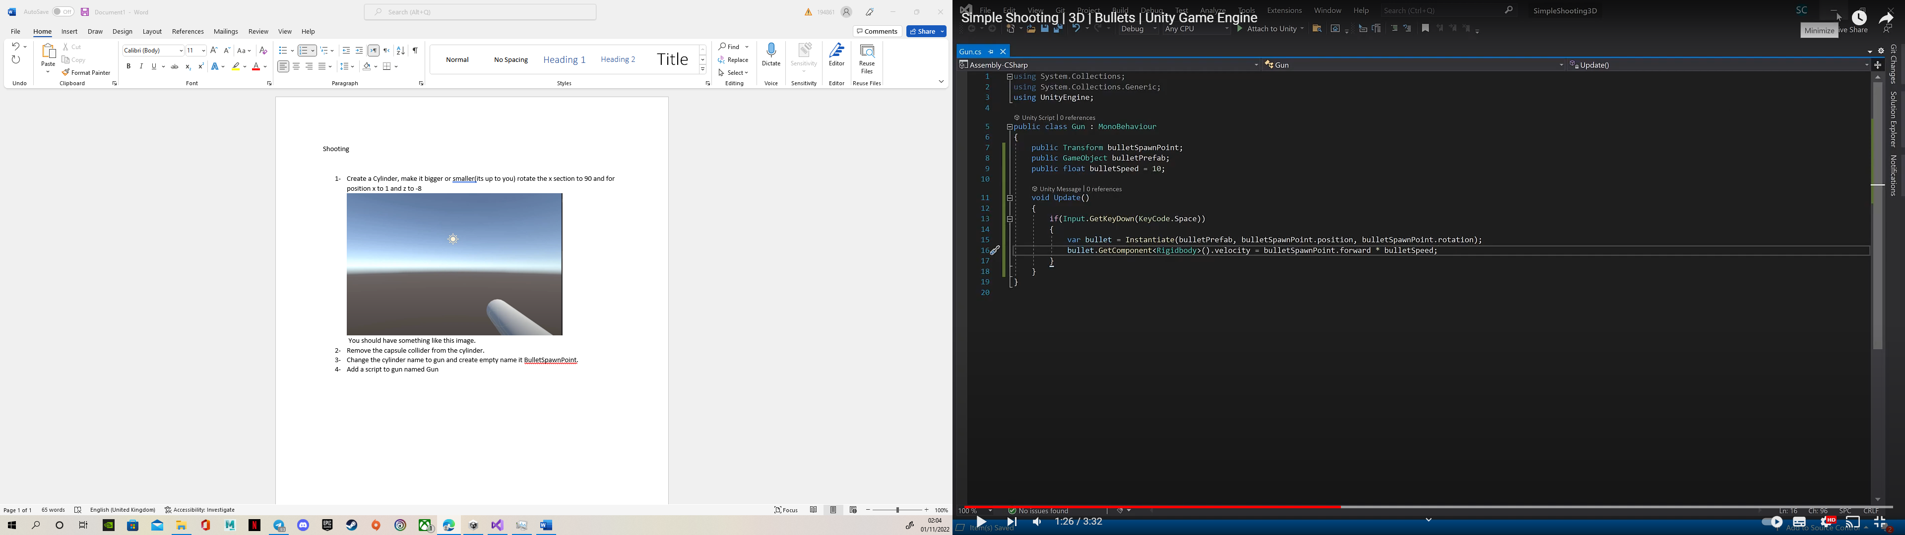
- In the gun’s inspector you should have something like this, drag the BulletSpawnPoint to the bullet spawn point section

- Now change the select BulletSpawnPoint and change position to front of the cylinder
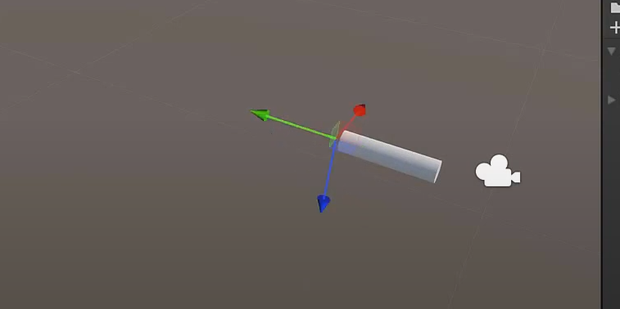
And rotate it to -90 so you have the blue arrow in the place that we had our green arrow

- It’s time for adding our bullets to the scene, create a 3d object, Sphere, and name it bullets
- Add rigidbody to the bullet and in the rigibody section we don’t want to use the gravity so make sure you don’t have the use gravity on.
- Reset the position and scale it to 0.5
- Add a script called bullet

Using System.Collections;
using System.Collections.Generic;
using UnityEngine;

public class bullet : MonoBehaviour
{
public float life = 3;
void Awake()
{
Destroy(gameObject, life);
}

private void OnCollisionEnter2D(Collision2D collision)
{
Destroy(collision.gameObject);
Destroy(gameObject);
}
}

- Drag the bullet that you have in your hierarchy to your project section and remove it from the hierarchy
- Select the gun and drag the bullet to the bullet prefab section
- Create an obstacle, 3d object, cube and name its obstacle and scale it to 5 so you can shoot it with your gun
- Now it’s time to shoot the obstacles, have fun

